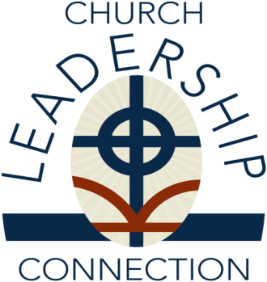

Presbyterian Church (U.S.A.)
Office of the General Assembly
Mid Council Ministries
Church Leadership Connection
Louisville, KY 40202-1396
1-888-728-7228, ext. 8550
Fax# (502) 569-5870
www.pcusa.org/clc

PIF Attestation for Teaching Elder

______________________________________________ is a member of the
(Name of Teaching Elder)

Presbytery of _____________________________________________________
(Name of the Presbytery)

As of this date, no allegations or charges are pending against the member, nor is the member currently under judicial censure limiting the ministry or under supervised rehabilitation.
The receiving body should always call the presbytery to ask for further information about any applicant, including their ministry and activities within the presbytery of membership.

Presbytery Stated Clerk

Signature ______________________________________________________

Print Name_____________________________________________________

Date__________________________________________________________

