**Intercultural Ministries: The Next Stepping Stone to Diversity in the Church**

by Sterling Morse

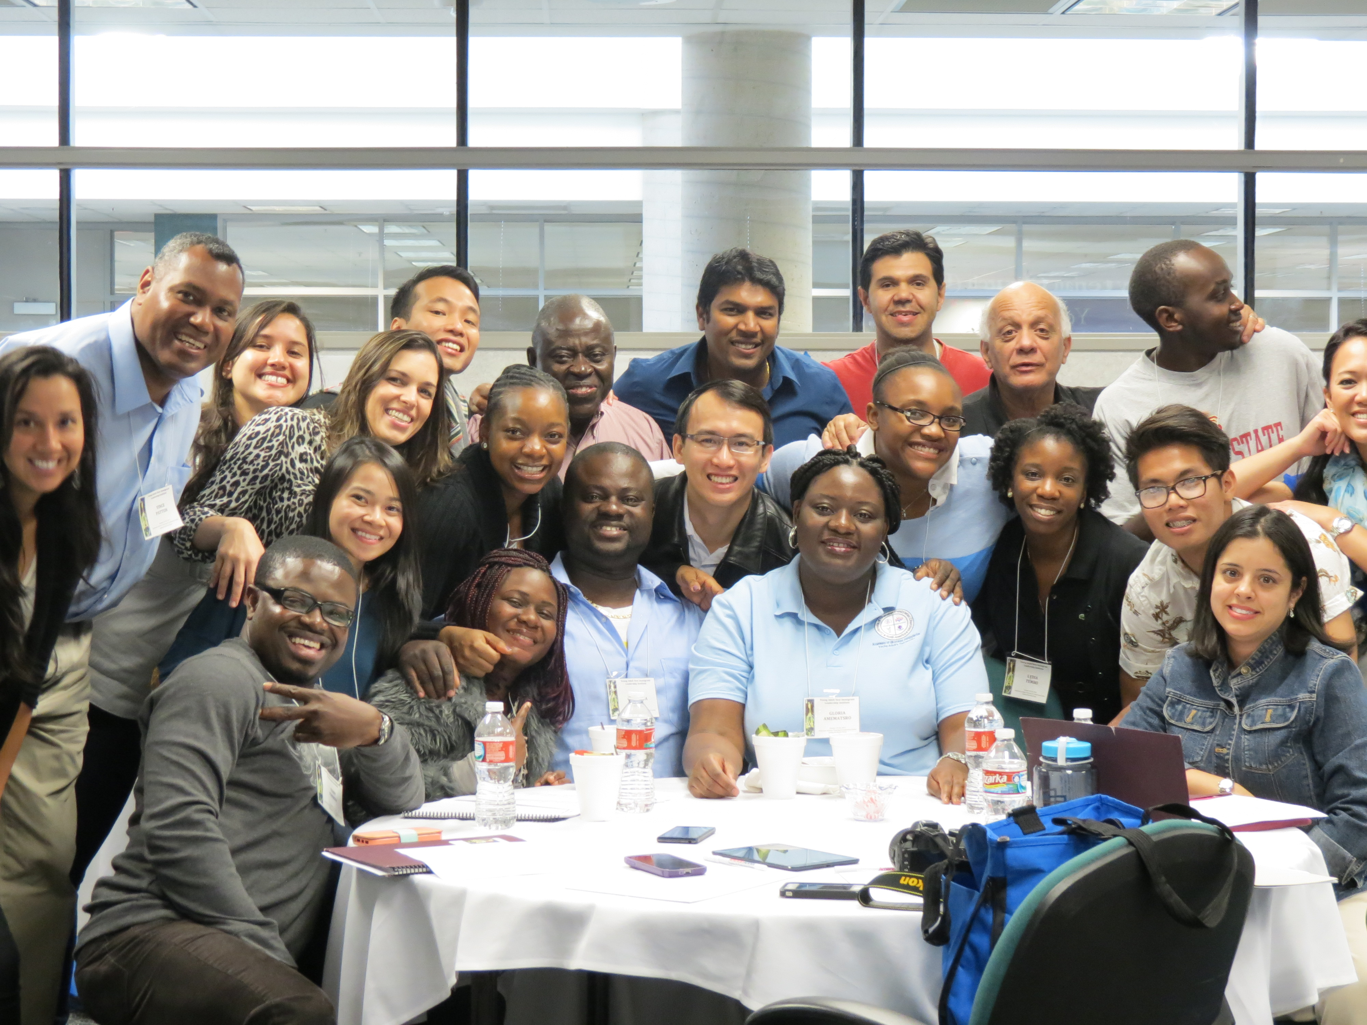

Those who attended the Multicultural Dinner and Celebration at Fort Street Presbyterian Church during the 221st General Assembly (2014) experienced a prophetic moment. The guest speaker, Dr. Rodger Nishioka, associate professor of Christian education at Columbia Theological Seminary, told those in multicultural and cross-cultural ministries that it is time to move on to the next stage toward becoming a more diverse and inclusive church: that of *intercultural ministries*.” In calling the church to intercultural ministries, he did not condemn the stages that preceded it—mainly multicultural and cross-cultural ministries. Instead, Nishioka celebrated each for playing timely roles as stepping stones to advancing the church across the deep, and sometimes troubling, waters of social change and progress in its quest to becoming racially and culturally diverse and generationally inclusive.

Several years ago, the PC(USA) made the leap from social integration to embrace the multicultural church movement. Demographic shifts and a new openness to creating what Rev. Dr. Martin Luther King Jr. called the “beloved community” encouraged our congregations to open their doors and welcome people of other races, ethnicities, cultures, and backgrounds into their life and mission in Christ. Thanking God for the magnificent journey thus far, the time now begs for the PC(USA) to make a progressive step.

Presbyterian Mission Agency Executive Director Linda Valentine shared with those gathered at the dinner that she had attended a family wedding at which the bride, groom, and wedding party were of many races and cultures. She said that the world has changed, and her children engage interculturally.

Rev. Dr. Rhashell Hunter, director of Racial Ethnic & Women’s Ministries, greeted the group, saying, “Friends, today is an opportunity to explore what we believe is our cross-cultural/intercultural mission and vision for the changing landscape in the church.”

Nishioka discussed definitions of multicultural, cross-cultural, and intercultural communities and described the progression within the church and society that has prompted the need to engage in intercultural ministries:

In **Multicultural communities,** *we live alongside one another. We value tolerance, and celebrate one another’s culturally distinctive cuisine, dress, music, dance, and related outward expressions of culture. It usually requires only superficial and polite social interaction.*

Imagine season ticket holders at sporting events. They share the same box, sit next to each other at every home game, root for the same team year after year, but at the same time live in isolation from one another, unaware of and not involved in the reality of each other.

In many of our congregations in general, and particularly in multicultural congregations, people are quietly struggling with hard questions to which there are no easy answers. While glorious and joyous encounters often occur in multicultural settings, these events tend to fall short of deeper engagement and learning.

In **Cross-Cultural communities,** *there is some reaching across boundaries. We try to build bridges of relationship between our cultural communities by sharing, listening, learning, and being open to changing. It usually requires intentionality, and programs of education and community building*.

Even as we forge ahead to build a diverse community, power and justice dynamics, which continue to loom large, are seldom discussed. The results can lead to retardation in mutual involvement, learning, and growth.

In **Intercultural communities** *there are comprehensive mutuality, reciprocity, and equality. Our social structures and everyday interactions are defined by justice, mutuality, respect, equality, understanding, acceptance, freedom, diversity, peacemaking, and celebration. Intercultural community hopes to take us deeper than multicultural or cross-cultural models of community.*

Nishioka contends that intercultural ministry is the gateway to effective engagement with youth and young adults. Outside of the church, many are experiencing intercultural life as a norm, attending schools that are global in makeup and where in some cases 30 or 40 languages are spoken. Socially, youth and young adults have crossed racial and cultural boundaries and are relating to one another in ways that 50 years ago Dr. King referred to as “a dream.” Lacking this creative movement in their home churches, many young people have opted to participate in church communities that reflect the world as they know it.

Living interculturally is moving from merely creating space for diverse people to gather and culturally share, to what our friends in the United Church of Canada refer to as “becoming radically welcoming the call to live together in intentional ways where there is mutual recognition and understanding of cultural differences.”

Recently, I collaborated with First Presbyterian Church, Champaign IL on the challenges of becoming an intercultural worshiping community. In the last two years 50 members from Central Africa, mostly from the Democratic Republic of Congo, began attending worship. Together, we began the discussion of what it means to enter into new community and maintain cultural authenticity.

At the core of intercultural ministries is empathy—the ability and desire to move pass the surface of relationship, and stand in the shoes of others, to see what they see, to feel what they feel, and then, as one in Christ—walk through these experiences together.

The office of Cross Cultural and Intercultural Ministries will partner with mid councils, congregations, and groups in making the PC(USA) a radically welcoming community for all. Please contact Sterling Morse, coordinator of Cross Cultural and Intercultural Ministries, at [sterling.morse@pcusa.org](mailto:sterling.morse@pcusa.org) for more information.