WIRELESS PHONE ORDER FORM/REQUISITION

FILL OUT COMPLETELY PRESBYTERIAN IT PURCHASING OFFICE
OBTAIN AUTHORIZATION 100 Witherspoon Street, Louisville, KY 40202

RETAIN COPY FOR YOUR FAX# 502-569-5163

RECORDS

**FORWARD TO Information Technology @Helpdesk.pcusa.org
OFFICE: | TELEPHONE: |  | FAX # | ROOM NUMBER:
REQUESTOR NAME |  | REQUESTOR SIGNATURE
DIRECTOR SIGNATURE |  | PRINT DIRECTOR NAME |  | DATE SUBMITTED:

PLEASE COMPLETE SEPARATE REQUISITION FOR EACH TELEPHONE/SERVICE REQUESTED

SELECT PHONE AND SERVICE OPTION
Please select iPhone Model  ____ iPhone SE  ____ iPhone XR  **Contact Steve Maier for color optiondans |  |  |  | Apple iPhone  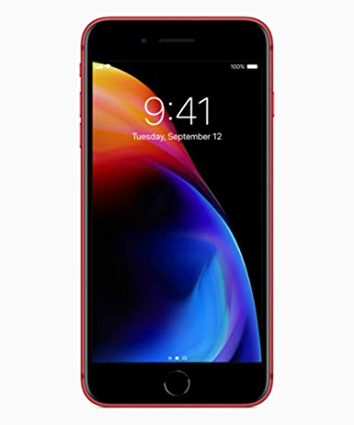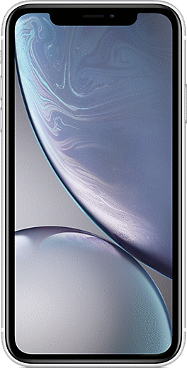 |  |  |  |  |  |  | Mifi Hotspot  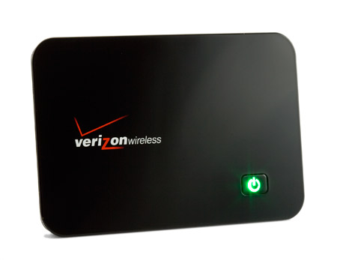  $43.00/month
Verizon (No Contract Required)
International Data Roaming Plan

EXTRA PHONE ASSESSORIES:

_____Power/Wall Charger (price varies)

_____Car Charger (price varies)

PHONE SERVICE AND/OR DATA SERVICE IS FOR:__________________________________________________________
EMPLOYEE NAME Current Cell Phone #

Please allow 2 weeks (10 working days) for delivery
Note: If your current personal cell phone number is rolled to the PCUSA business account, it will not be returned upon separation of employment.

**(1) Country |  |  |  |  |  | **(2) Employee ID |  |  |  |  |  |  | ** (3) Committee
Account Distribution
Ent | Dir | Prog | Office |  | Obj | Account  Code | Class | Project | **T  Code | Amount |  | Description

NOTE: The telephone number that is assigned to the device is property of PC(USA) and is not transferrable to personal accounts upon employment separation.

